AJAYA GHIMIRE

Assignment 07

Use SQL commands to finish the questions. Please show BOTH SQL commands and results in your answers. For the questions do not need execution, you DO NOT have to show the SQL running results.

1. Create a view named MAJOR_CUSTOMER. It consists of the customer ID, first name, last name, balance, credit limit, and rep ID for every customer whose credit limit is $500 or less.
   1. Write and execute the CREATE VIEW command to create the MAJOR_CUSTOMER view.

ANS: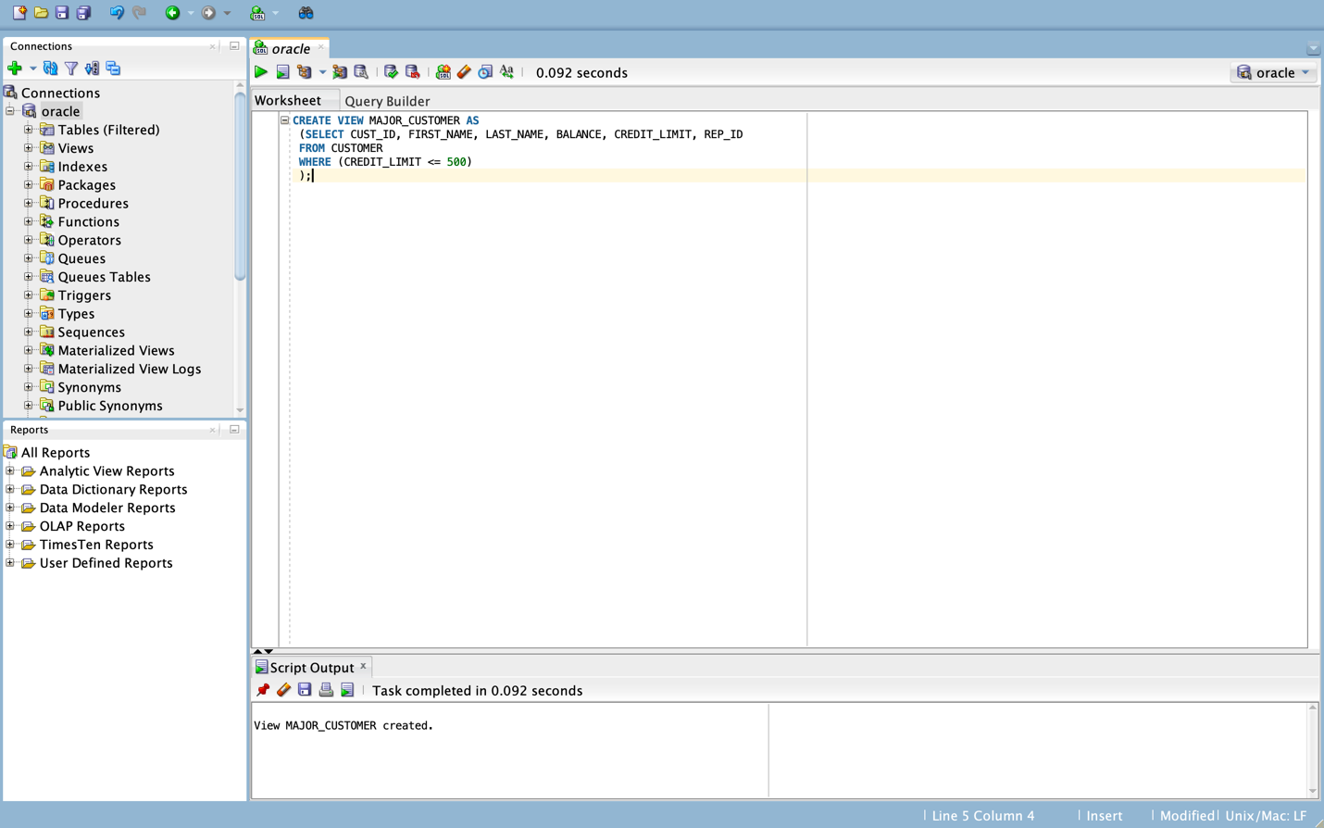

* 1. Write and execute the command to retrieve all columns of each customer in the MAJOR_CUSTOMER view with a balance that exceeds the credit limit.

ANS:

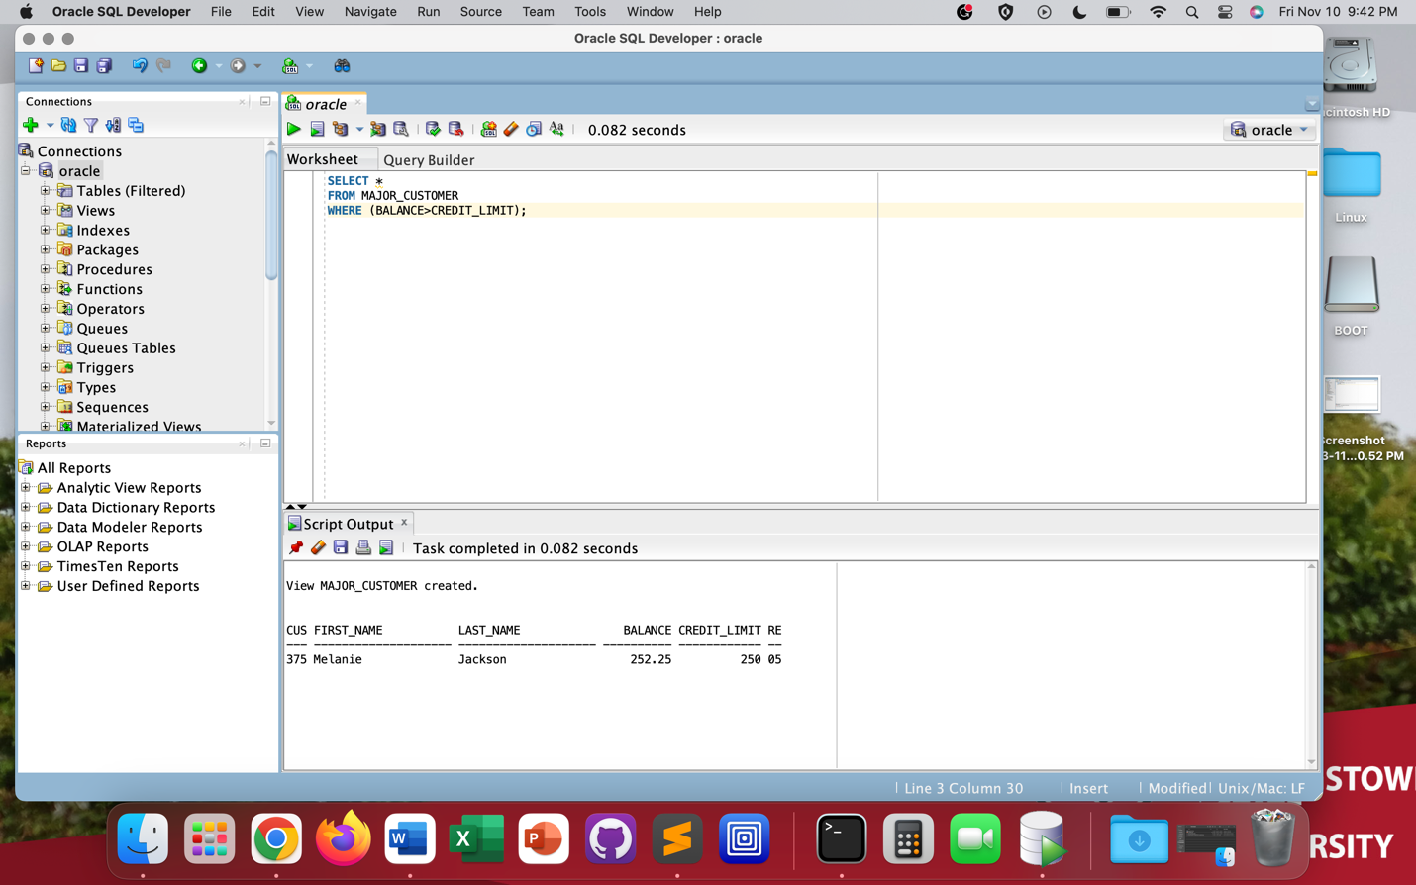

1. Write, but DO NOT execute, the command to revoke all privileges on ITEM table from user ‘Ashton’.

ANS:

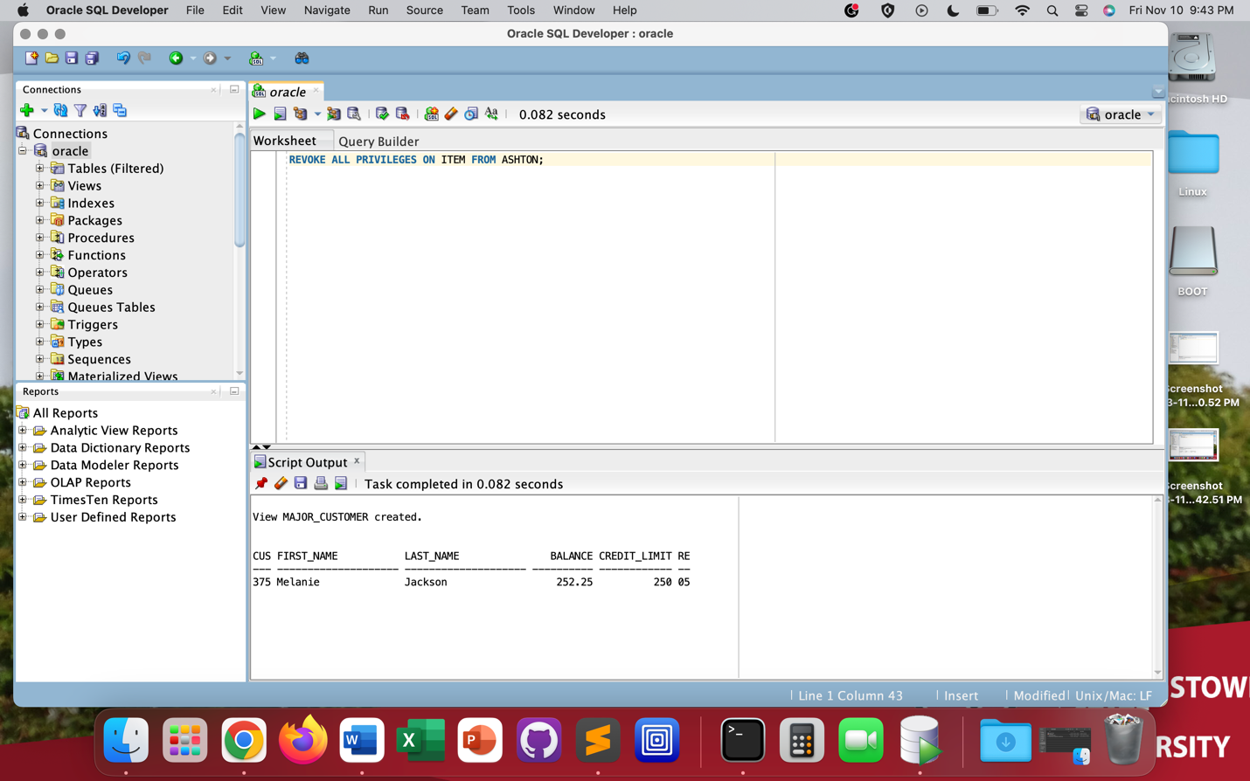

1. Create an index named ITEM_INDEX1 on the ITEM_ID column in the INVOICE_LINE table.

ANS:

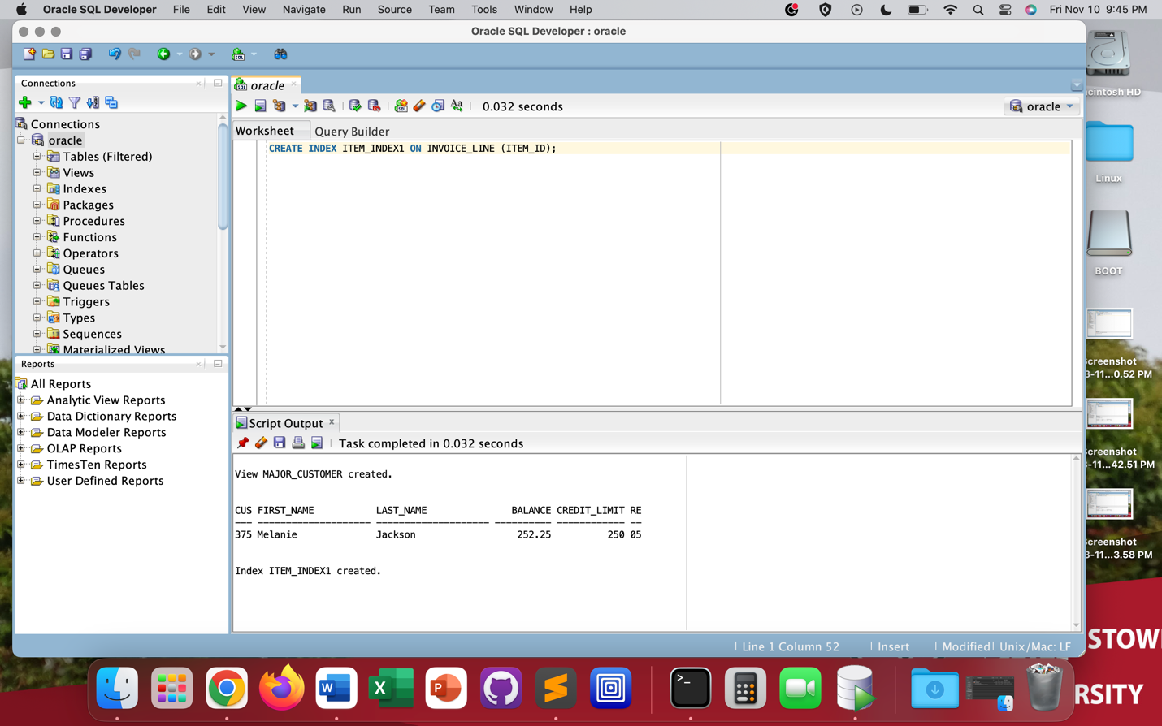

1. Add the INVOICE_NUM column as a foreign key in the INVOICE_LINE table which references INVOICE_NUM column in the INVOICES table.

ANS:

